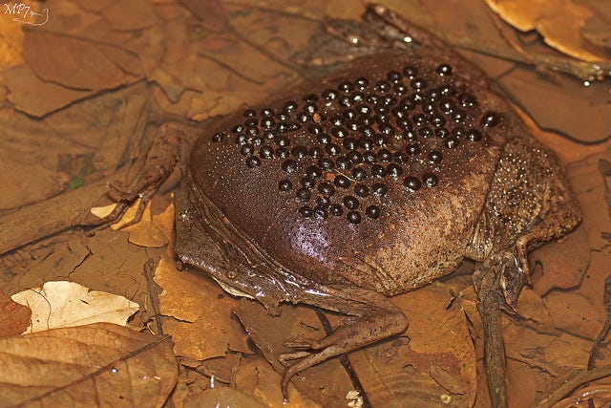

Suriname Toad - The Suriname Toad is an aquatic frog that is native to the rivers and swamps of South America. They are generally brown in color and have a flat pancake-like body. Unlike most frogs, Suriname Toads don't lay eggs. Instead, a female frog will carry eggs on her back.

Budgett's Frog - Budgett's Frogs are native to South America. They are intelligent and often kept as pets because of their appearance. These frogs can grow up to four inches in size. They are nocturnal and sometimes show cannibalistic behavior.